In this application I developed an application which will be used to find geographical locations of any area and we can also find weather information of a particular area. For developing this application I used HTML, JQUERY, and CSS.

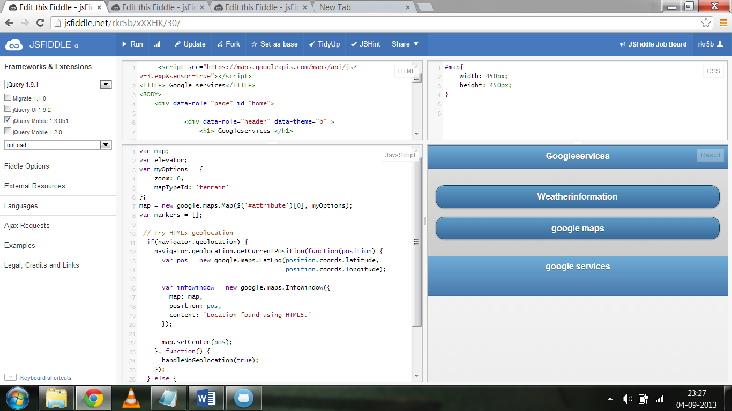

When you click on weather information it displays screen like below.

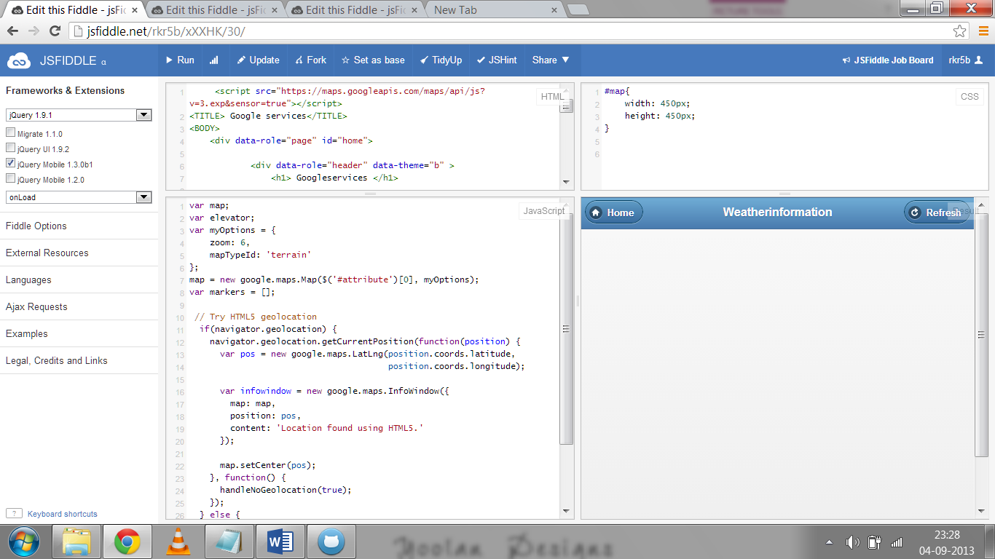

When you click on again weather information it displays screen like below.

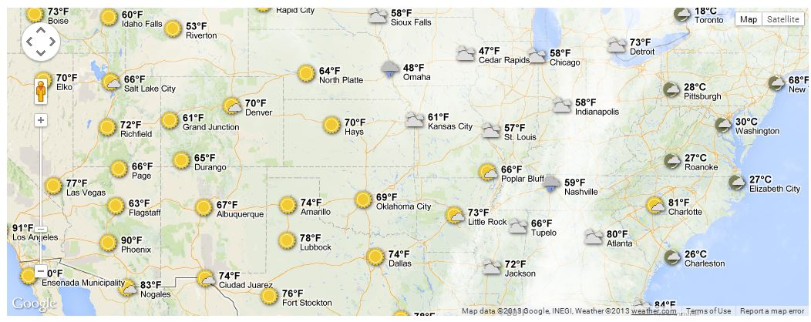

When you click on Google maps it displays the screen like below

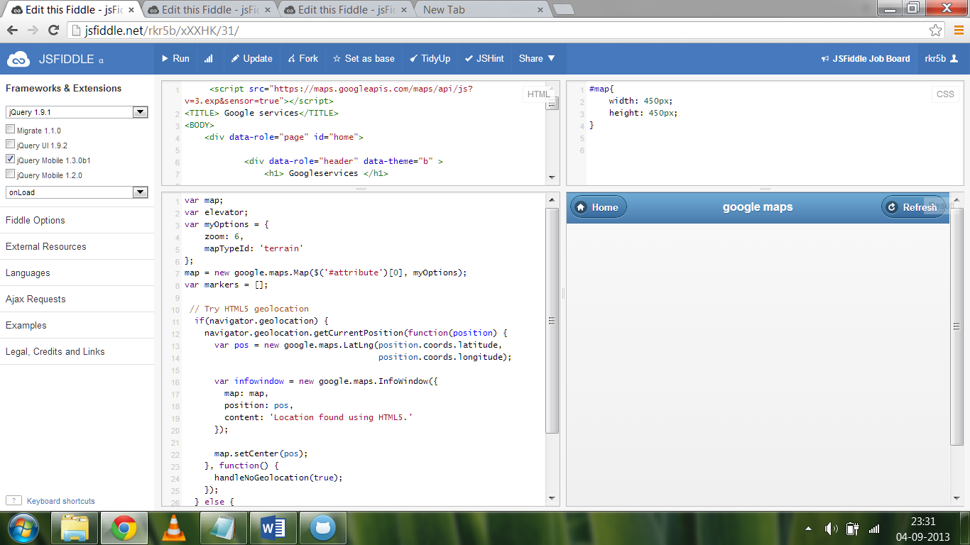

When you again click on Google maps it displays the screen like below

